APPENDIX B — PRIMARY WINDOWS

Startup (splash screen)
When the program starts, a splash screen appears while the libraries load; the progress bar tracks each stage (NumPy → Pandas → CuDAL core → SciPy → Matplotlib → export engines). The footer links to the project repository.

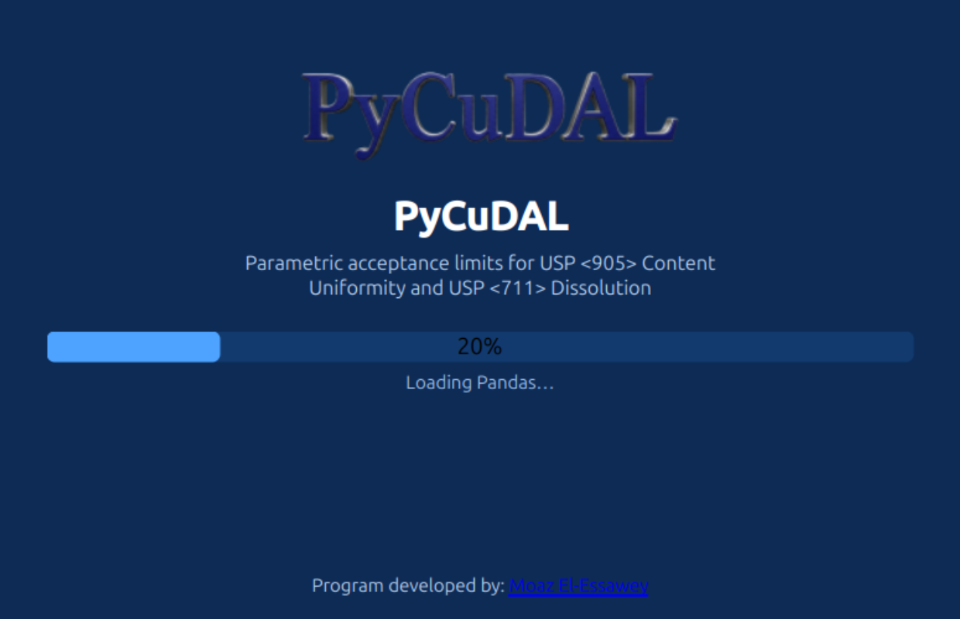

The main window
The main window contains: a header (logo + scope), an action toolbar, the four scenario tabs, and a status bar whose right side credits the author.

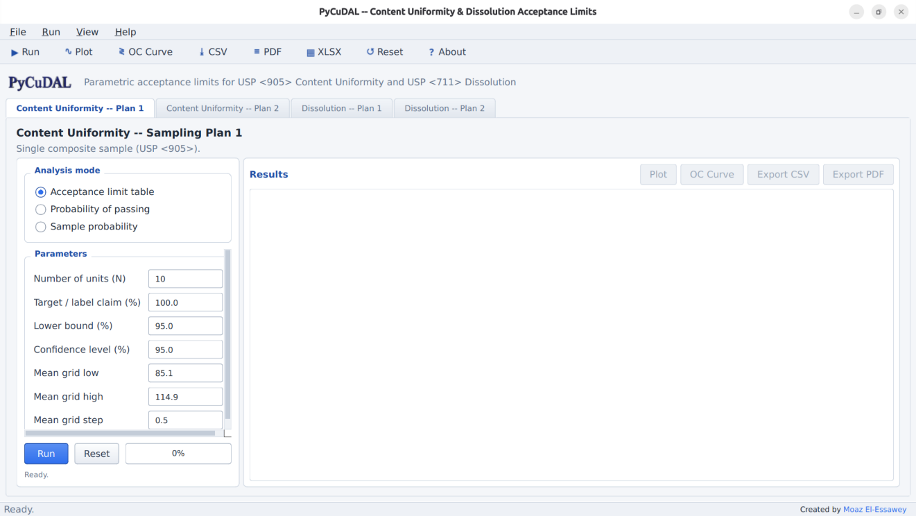

Toolbar / Run menu

Button | Action | Shortcut
▶ Run | Run the selected analysis | Ctrl+R
∿ Plot | Open the plot dialog for the current results | Ctrl+P
≷ OC Curve | Open the OC-curve dialog | Ctrl+O
⤓ CSV / ≡ PDF / XLSX | Export current table / PDF / all results | Ctrl+E (CSV)
↺ Reset | Restore default parameters
? About | About / help dialog | F1

The File menu adds Save settings now (Ctrl+S) and Exit; View switches tabs (Ctrl+1…4); Help opens the online documentation and issue tracker. Parameters, mode, active tab and window geometry are persisted between sessions.

A scenario tab
Every tab has the same layout: an Analysis mode panel (three radio buttons), a scrollable Parameters panel (one card per mode, live-validated entries with tooltips), a Run row (Run, Reset, progress bar, status line) and the Results panel.
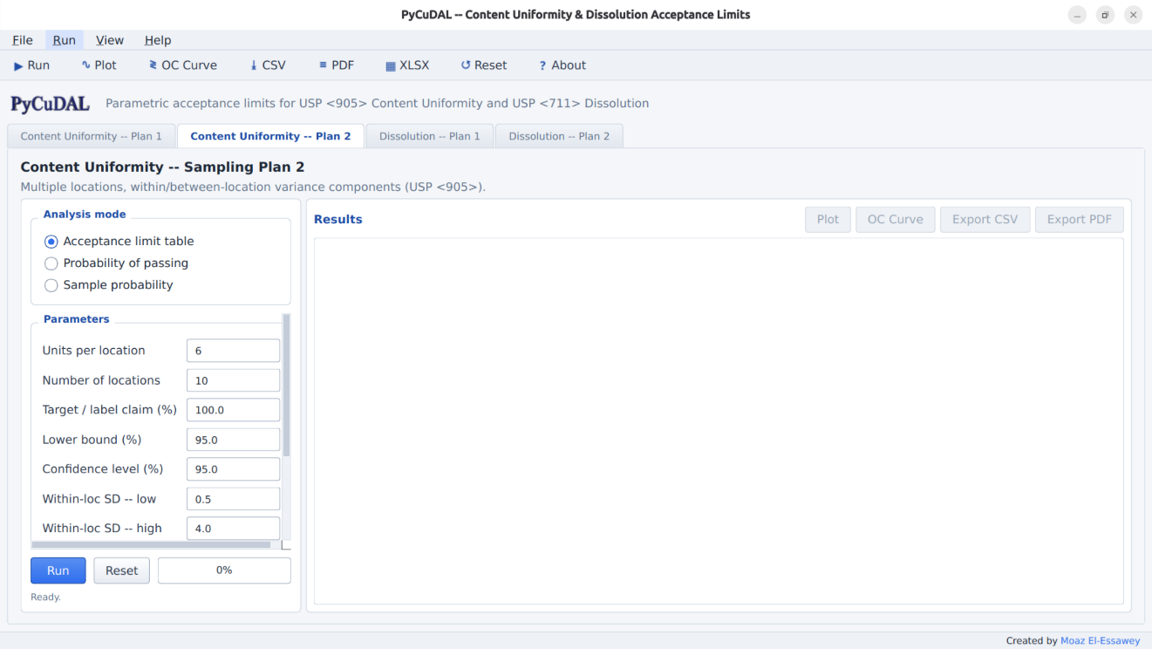
The Results panel shows the computed table with zebra striping, click-to-sort headers, conditional coloring of probability values (red < 0.80, green ≥ 0.90), a row counter, and Ctrl+C copy of the selection.

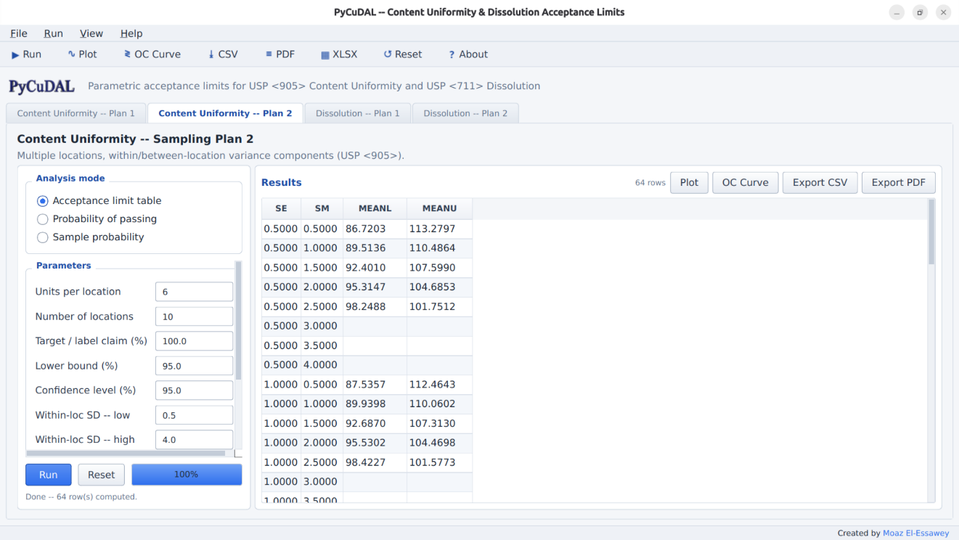

Content Uniformity / Sampling Plan 1
The user enters the sample size (number of dosage units tested), the target (usually the average of potency limits), the coverage percentage (usually 90 or 95) and the confidence level (usually 90 or 95), plus the mean grid for the table (default 85.1–114.9 by 0.5).
1) Acceptance limit table. The output lists, for each candidate mean, the corresponding acceptance limit on the CV:
MEAN (% CLAIM) CV (%) MEAN (% CLAIM) CV (%)
85.1 0.48 100.0 4.18
85.2 0.51 100.1 4.16
... ...
114.9 0.35
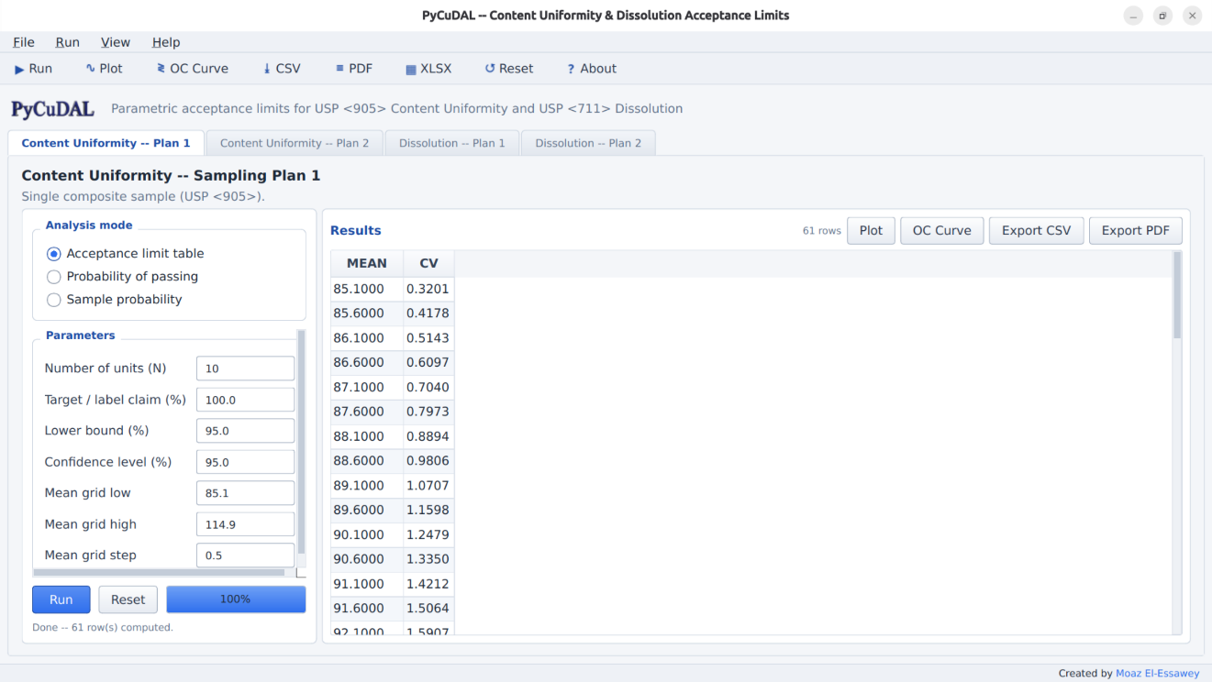
2) Probability of passing. The user provides "true" values for the population mean U and coefficient of variation (CV/RSD) as grids (defaults U 95–105 × 2.5, CV 1–4 × 1); the program calculates the probability that sample results fall within the acceptance limits:
U CV PROBABILITY OF PASSING
95 1 1.00000 100 1 1.00000
95 4 0.05220 100 4 0.56434

3) Sample probability. The user enters the sample mean and sample CV (defaults 100, 2.0); the output is the lower bound (e.g. mean 100, CV 4 → 0.98003).

Content Uniformity / Sampling Plan 2
The user enters the number of locations, the number of dosage units per location, target, coverage and confidence, and (for the table) grids of the within-location SD (SE) and between-location SD (SM) (defaults 0.5–4.0 × 0.5). Table entries are lower (LL) and upper (UL) limits on the mean; SE is the pooled within-location standard deviation; all SDs and means are in % claim.
STANDARD DEVIATION OF LOCATION MEANS
0.1 0.2
SE LL UL LL UL
0.1 84.8 115.2 84.8 115.2
0.2 84.7 115.3 84.8 115.2



For the evaluation the user provides true U, within-location SD and between-location SD grids; for the sample probability the sample mean, within sample SD and between sample SD. [Note: the latter is just the sample standard deviation of the sample means, not a variance component!] Reference values: evaluation (U 95, SE 2.2, SM 2.2, 4×10 design) → 0.09180; sample (100, 2.2, 2.46) → 0.98750.

Dissolution / Sampling Plan 1
The user enters Q, the sample size, coverage and confidence (table grid step default 1.0). The table entry is the upper limit on the CV of 6 dissolution assays for each mean (80.2 → 0.09 … 100.0 → 4.97). Evaluation and sample modes mirror CU Plan 1 (defaults U 90–100 × 2.5, CV 1–4 × 1; sample mean 90, CV 3). Reference values: evaluation (95, 4) → 0.73988, (100, 4) → 0.81098; sample (100, 4) → 0.99824.

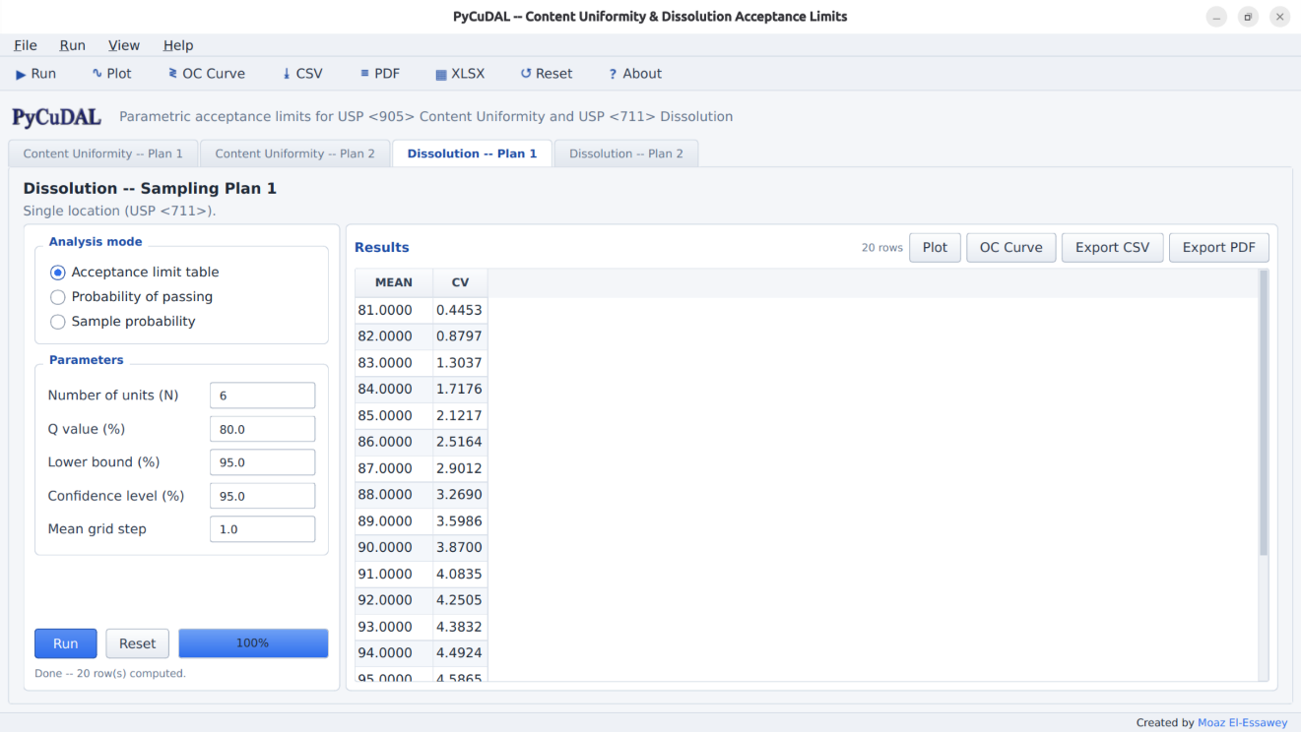

Dissolution / Sampling Plan 2
The user enters Q, locations, units per location, coverage and confidence, and SE/SM grids (defaults 1.0–5.0 × 1.0). Table entries are lower limits on the mean (e.g. SE 0.25 / SM 0.25 → 80.50). Evaluation and sample modes mirror CU Plan 2 (sample defaults 90, 2.2, 2.46; reference bound 1 for the 6×10 design).

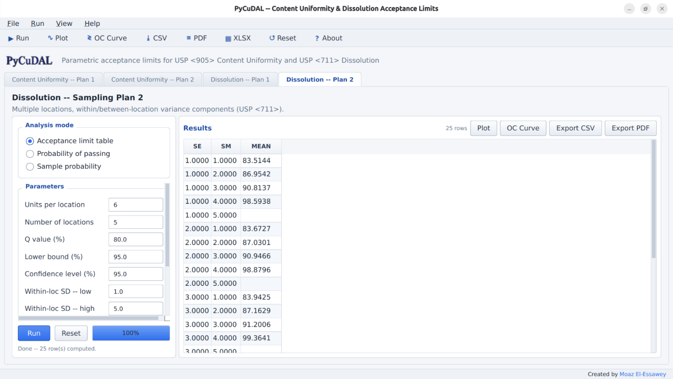

Plot dialog
Plot opens a modal dialog. Lines + spline draws the results as points with a cubic spline (Plan 2 tables draw one curve family per SM level, with a Z-axis selector when both LL and UL are present).

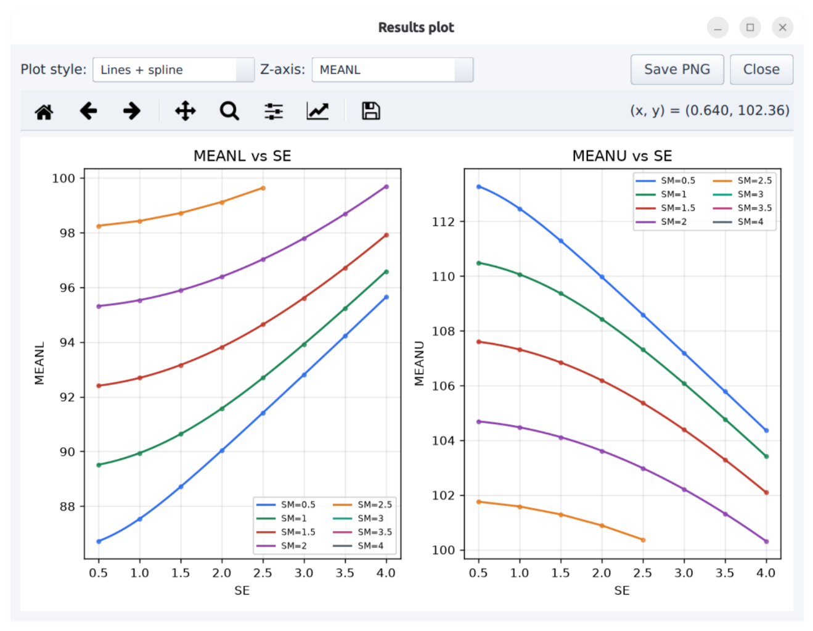

Heatmap (grid) draws a contour-filled surface for 3-column grids; probability surfaces include white 80 %/90 % threshold contours. Figures can be saved as PNG

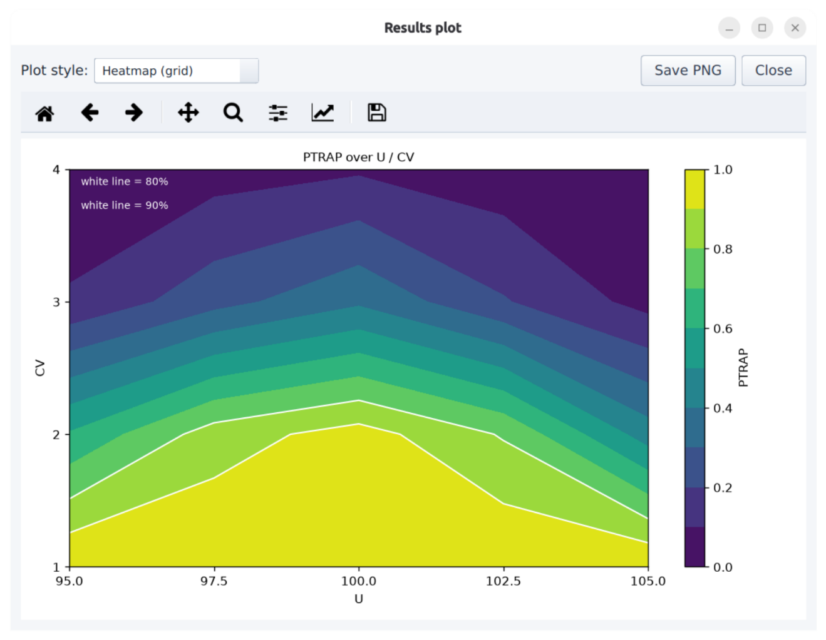

OC-Curve dialog
OC Curve overlays two operating-characteristic curves on one axes: the analytic probability of passing your computed acceptance-limit table, and a seeded Monte-Carlo estimate of passing the raw USP <905>/<711> multi-stage test itself. The X axis (true CV, true mean, or within-loc SD), the fixed companion parameters, the grid and the MC replication count are editable; dotted lines mark the 80/90 % levels.

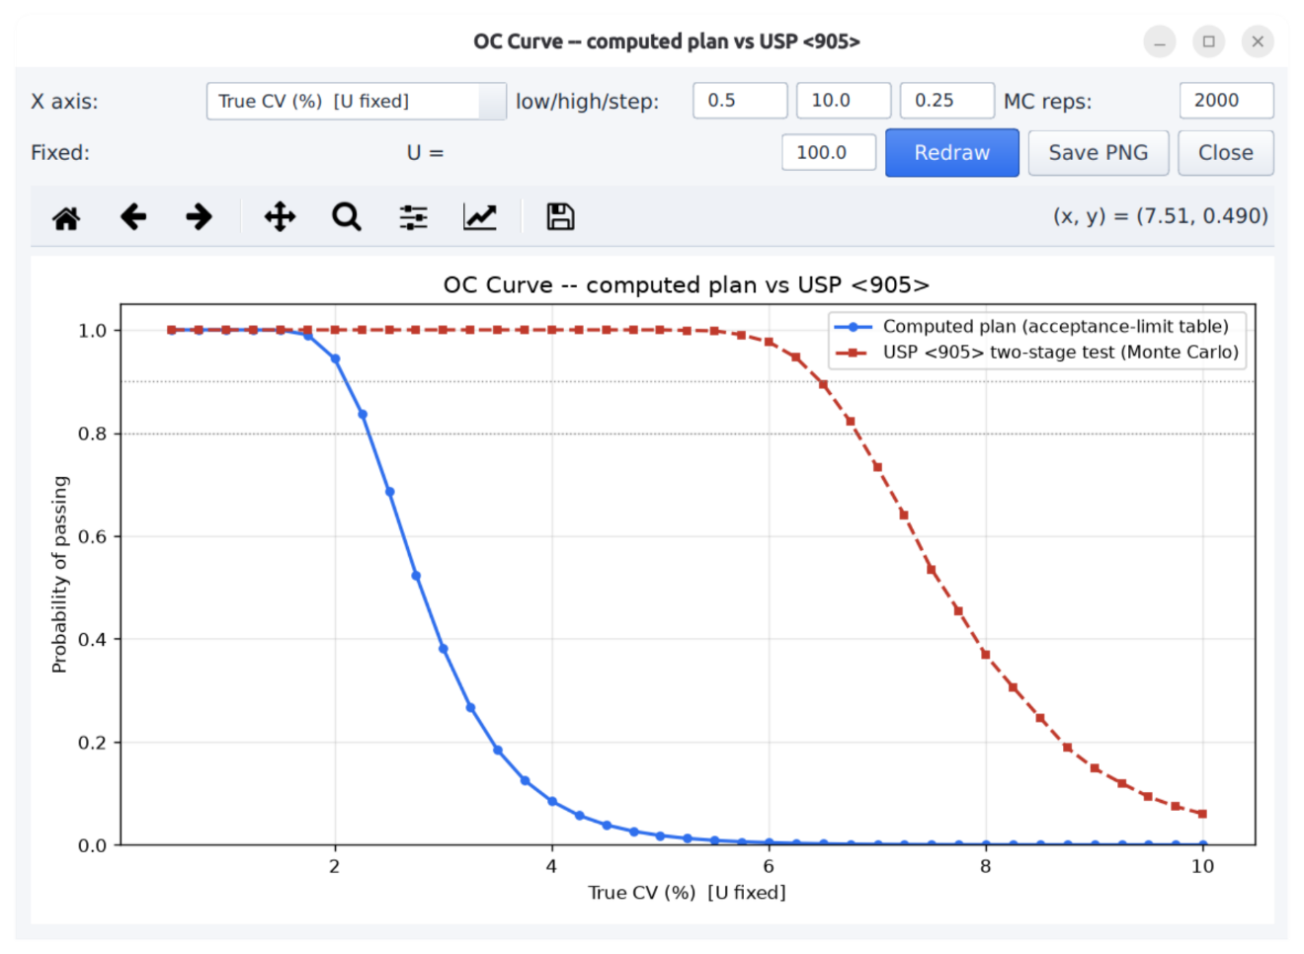

Exports
- CSV – the current table; PDF – SAS-listing style (Courier, wrapped blocks / SE×SM LL-UL matrices, 2 dp right-aligned, * for missing, title and headers repeated on every page); XLSX – one sheet per scenario.
- Default filenames describe their content, e.g. CUSP2-95x95-10Lx6N.pdf, DISP1-Q80-95x95-6N-EVAL.csv, CUSP1-95x95-10N-SAMPLE.pdf, …-plot.png, …-OC.png, PyCuDAL-all-results-<date>-<time>.xlsx.

